VPC Traffic Flow & Security
By Haroon Zaman | November 2025

Introduction
I am doing this project to understand how traffic flows inside a VPC and how AWS applies security at different layers. This stage is important because just creating a VPC is not enough — it must be properly routed and secured to function like a real-world cloud network.
By implementing these components, I aim to learn how AWS handles routing decisions, instance-level protection, and subnet-level security, which are essential skills for cloud engineers and network professionals.
In this project, I will perform the following tasks:
- Create a Route Table – To control the direction of traffic and define how packets travel inside and outside the VPC.
- Create a Security Group – To protect EC2 instances using a stateful firewall that monitors inbound and outbound rules.
- Create a Network ACL (NACL) – To secure the subnet level using a stateless firewall that filters traffic before it reaches any resource.
Route Tables:
A route table is a set of rules that determines how network traffic is directed within a VPC. It tells resources in subnets where to send packets, whether to other subnets, the internet, or virtual private networks. By configuring route tables, we control the flow of traffic and ensure that resources can communicate securely and efficiently.
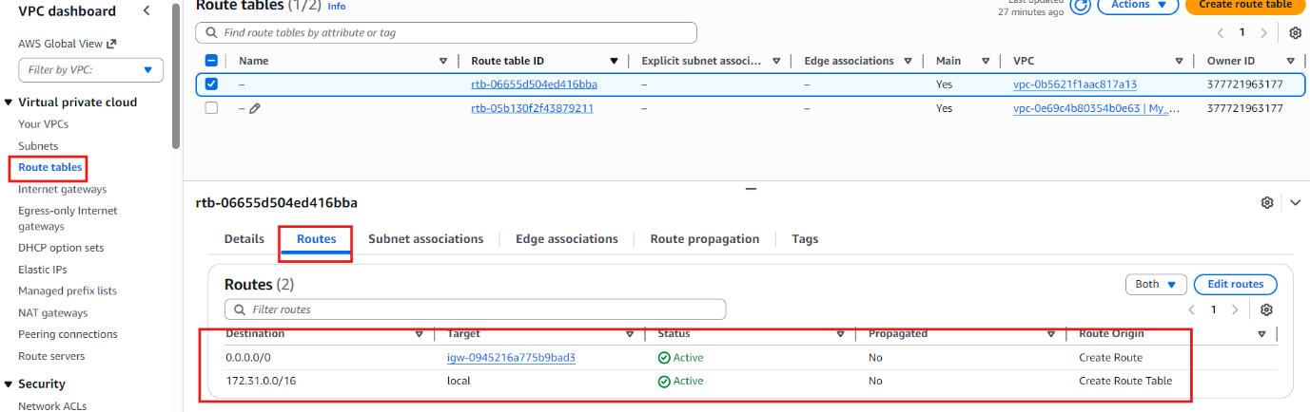
Since I already deployed a VPC, an Internet Gateway, and a Subnet, I moved on to create a Route Table. Without a route table, the subnet and gateway cannot communicate properly, and the VPC would not know how to send traffic to the internet or even within its own network. This step is necessary to define traffic directions and enable proper connectivity between all components.
Here’s what I observed and did:
- I clicked on Route Tables in the VPC dashboard. I found two route tables:
  - One was the default route table.
  - The other was automatically created when I created the subnet in my VPC.
- The default route table already had two routes defined:
  - 0.0.0.0/0 → igw-... → directs traffic to the internet through the default internet gateway.
  - 172.31.0.0/16 → local → manages internal traffic within the VPC.
- The CIDR block may not always be 172.31.0.0/16 — it depends on each unique VPC. What matters is that:
  - The CIDR block (e.g., 172.31.0.0/16) covers the entire IP range of the VPC.
  - The target local means all internal traffic should be routed to the resources inside the VPC correctly.
- The second route table was automatically created when I set up my custom VPC.
  - It only had one route that allowed traffic within the 10.0.0.0/16 CIDR block to flow inside the network.
  - There was no route to the internet gateway, which means traffic cannot leave the VPC yet.
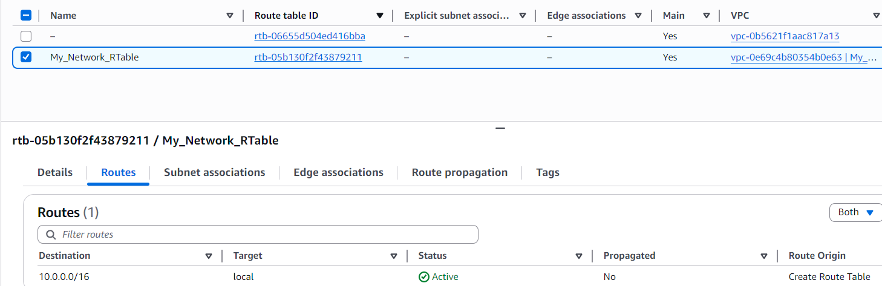
After reviewing the route tables, the first step I took was to rename the route table for better identification.
- I clicked the edit (pin) icon in the Name field.
- Then I renamed it to My_Network_Rtable so that it clearly represents the route table for my custom VPC.
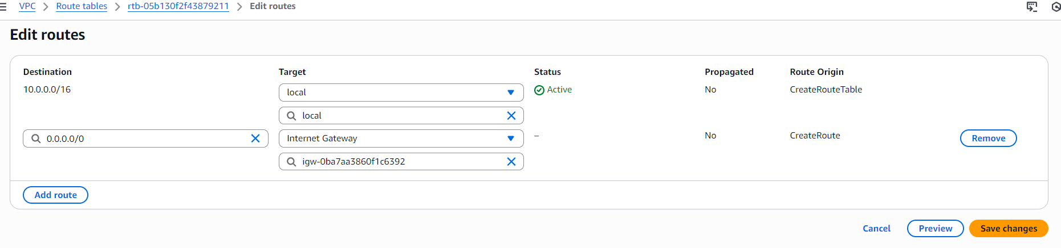
To configure internet access, I clicked on Edit routes at the bottom of the selected route table. This opened a new window where I had to define the destination and target:
- For Destination, I entered: 0.0.0.0/0 → this means all traffic going outside the VPC.
- For Target, I select the option local, then I selected Internet Gateway.
- From the list, I chose my internet gateway that I created earlier.
- Finally, I clicked Save changes to apply the route.
By adding this route, I allowed the resources inside my public subnet to send traffic to the internet through the Internet Gateway.
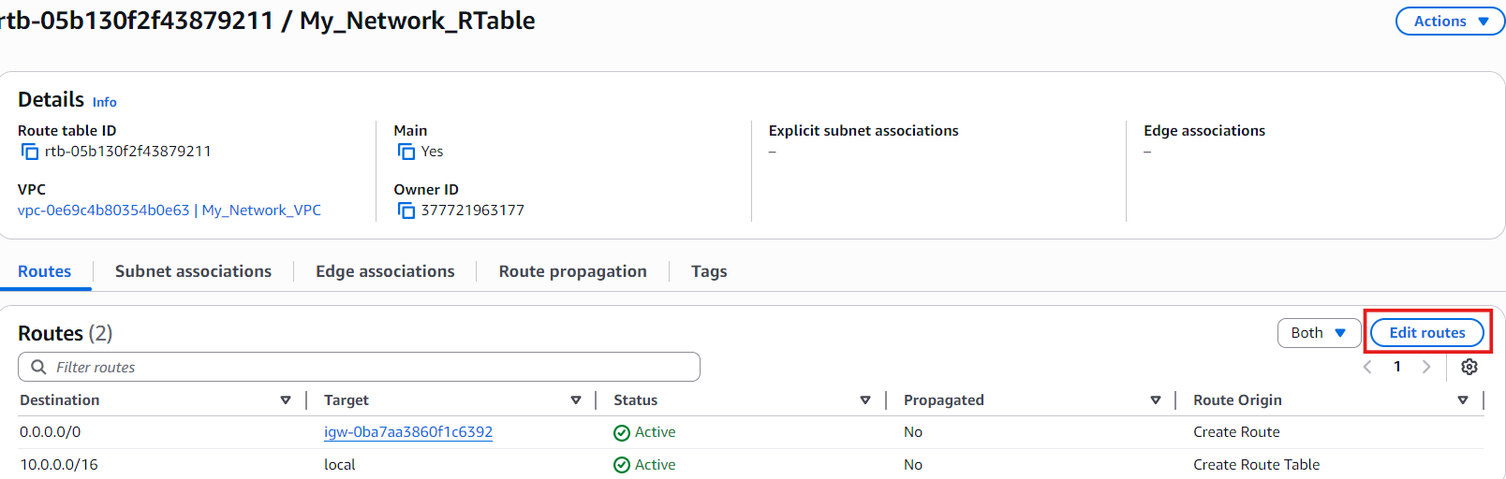
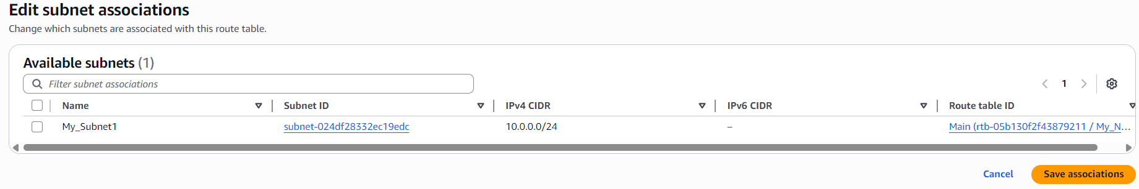
- Next, I moved to the Subnet Associations section of the route table. Under Explicit subnet associations, I clicked on the Edit subnet associations button on the right side.
- I simply selected my public subnet from the list.
- Then I clicked Save associations to finalize the process.
This step was important because even if the route table is correctly configured, it will not work until it is associated with the correct subnet. Associating the subnet ensures that all traffic coming from that subnet will follow the rules of this route table — including the route to the internet through the Internet Gateway.
Without this association:
- The subnet would still remain isolated.
- The resources inside the subnet would not be able to reach the internet.
- The routing rules would never apply to the network.
So, associating the subnet is what actually activates the route table and enables traffic flow based on the rules I defined.

Security Groups
A security group acts like a virtual firewall for individual AWS resources such as EC2 instances. It controls who can enter and who can leave, using rules based on IP addresses, protocols, and port numbers. Unlike route tables or network ACLs, security groups do not attach to the whole VPC or subnet — they are applied directly to each resource inside the subnet.
Every resource must be associated with a security group. If no security group is manually assigned during launch, AWS automatically applies the default security group created when the VPC was set up.
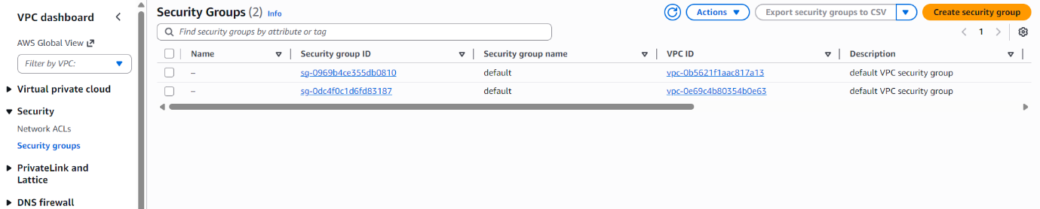
To create my own security group, I first went to the VPC console. In the left side panel, under the Security section, I clicked on Security Groups.
- I noticed that there were already two security groups present:
  - One was the default security group created automatically by AWS for the default VPC.
  - The second one was automatically generated for my custom VPC when I created it.
This helped me understand that AWS always ensures at least one security group exists per VPC, even if I don’t create one manually.
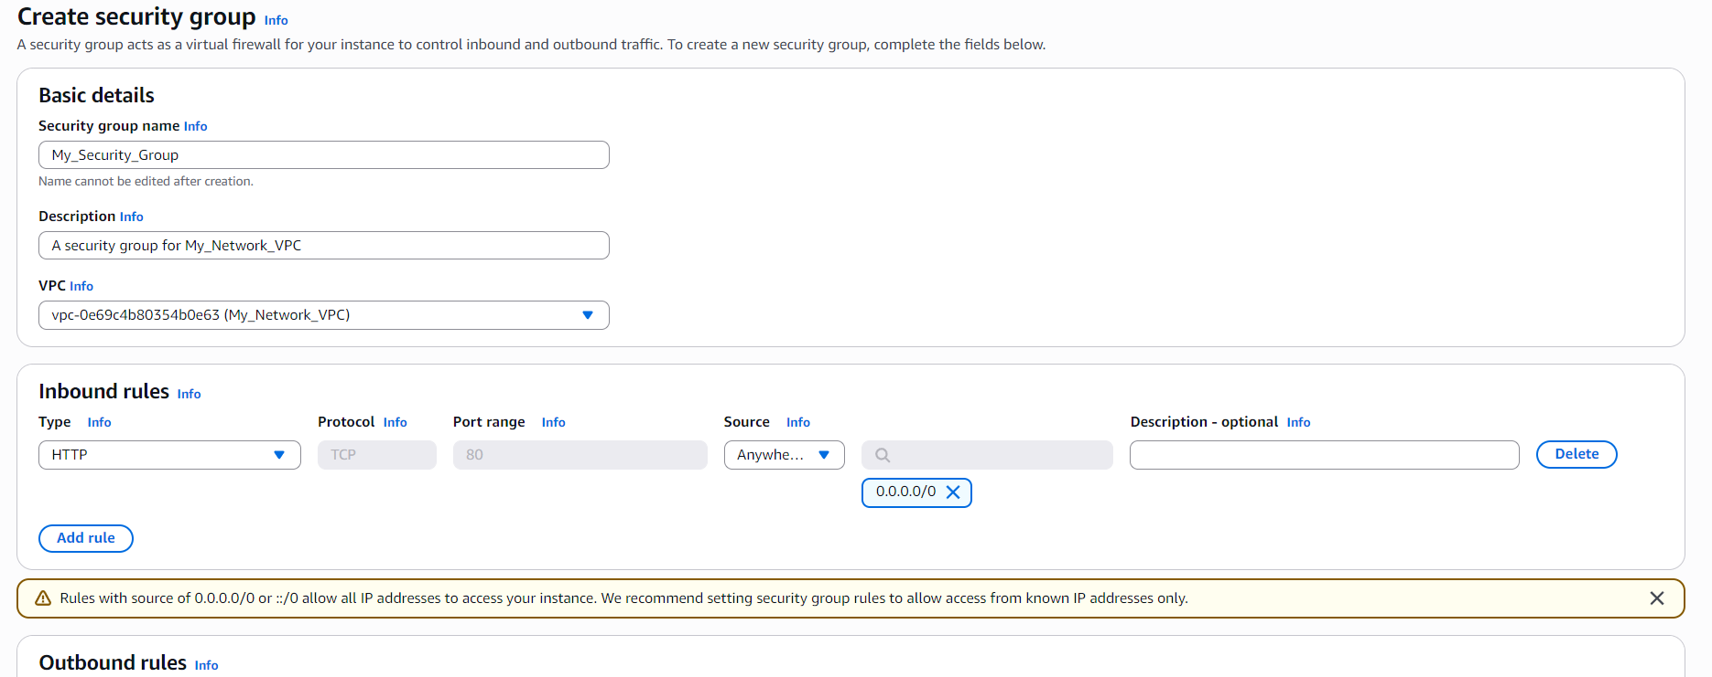
Even though AWS automatically created a security group for my VPC, I decided to create my own custom security group for practice and better understanding.
- I clicked on Create security group.
- I named it My_Security_Group and added a short description.
- Then I selected the VPC that I created earlier as the network for this security group.
Next, I configured the rules:
- I added one inbound rule allowing HTTP traffic (port 80) from anywhere.
  - This was just for practice, because allowing unrestricted access is considered risky in real production environments.
- For outbound rules, AWS had already added a default rule allowing all traffic to go outside, which means any resource can reach the internet if needed.
After reviewing everything, I clicked on Create Security Group to finish the setup.
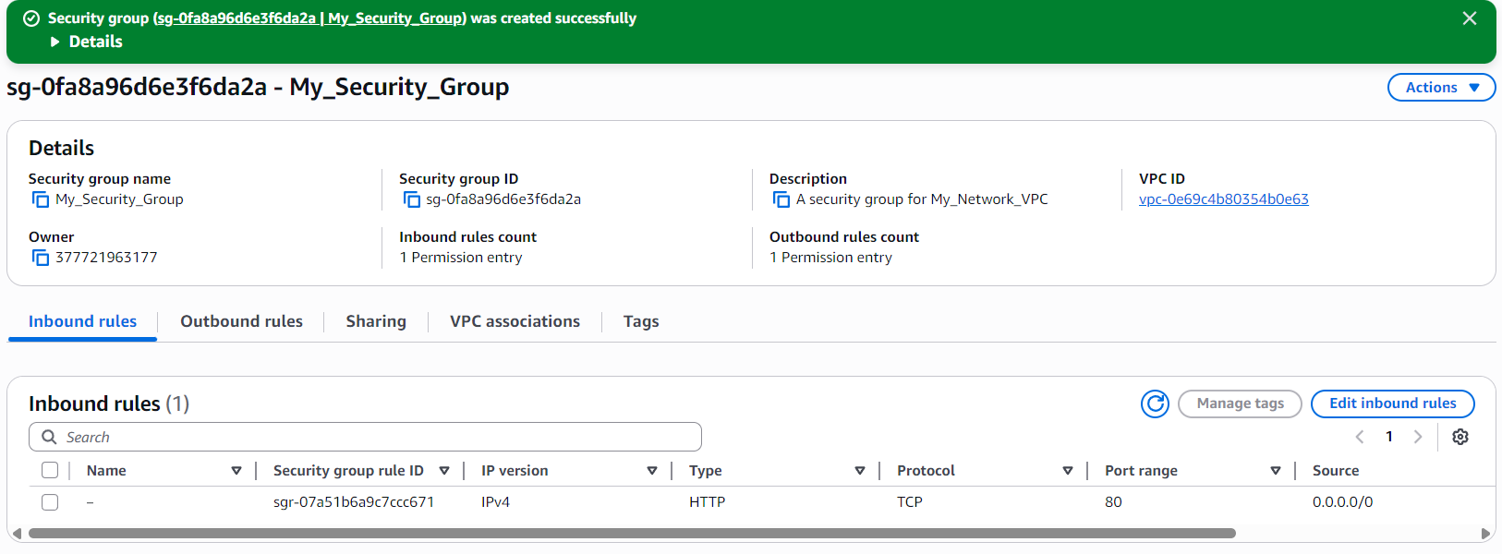
With all settings applied, my security group was successfully created and is now ready to protect any resource I launch inside my VPC.

Network ACLs (NACLs)
Network ACLs act as traffic filters at the subnet level. They work like traffic police officers standing at every entry and exit point of the subnet, inspecting every incoming and outgoing data packet. Each packet is checked against a list of rules in the ACL table before it is allowed through.
Unlike security groups, which apply to individual resources, Network ACLs apply to entire subnets — making them the first layer of defense before traffic reaches any resource inside the network.
Network ACLs are:
- Stateless — they do not remember past traffic.
- Subnet-level firewalls — protecting everything inside the subnet.
- Based on numbered rule evaluation — lowest rule number is checked first.
- Able to allow or deny traffic explicitly.
They work together with security groups to form a strong layered security model inside AWS networks.
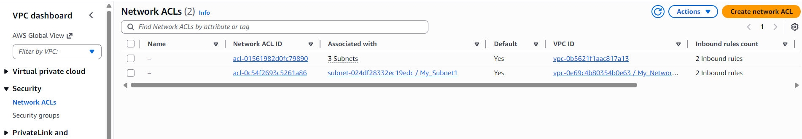
In the same Security section of the VPC console, I found Network ACLs and clicked on it.
- I noticed that there were already two ACLs present:
  - One was automatically created for the AWS default VPC.
  - The other was automatically created when I set up my custom VPC and subnet.
This showed me that AWS always provides default ACLs for every VPC and subnet, even if I don’t create one manually.
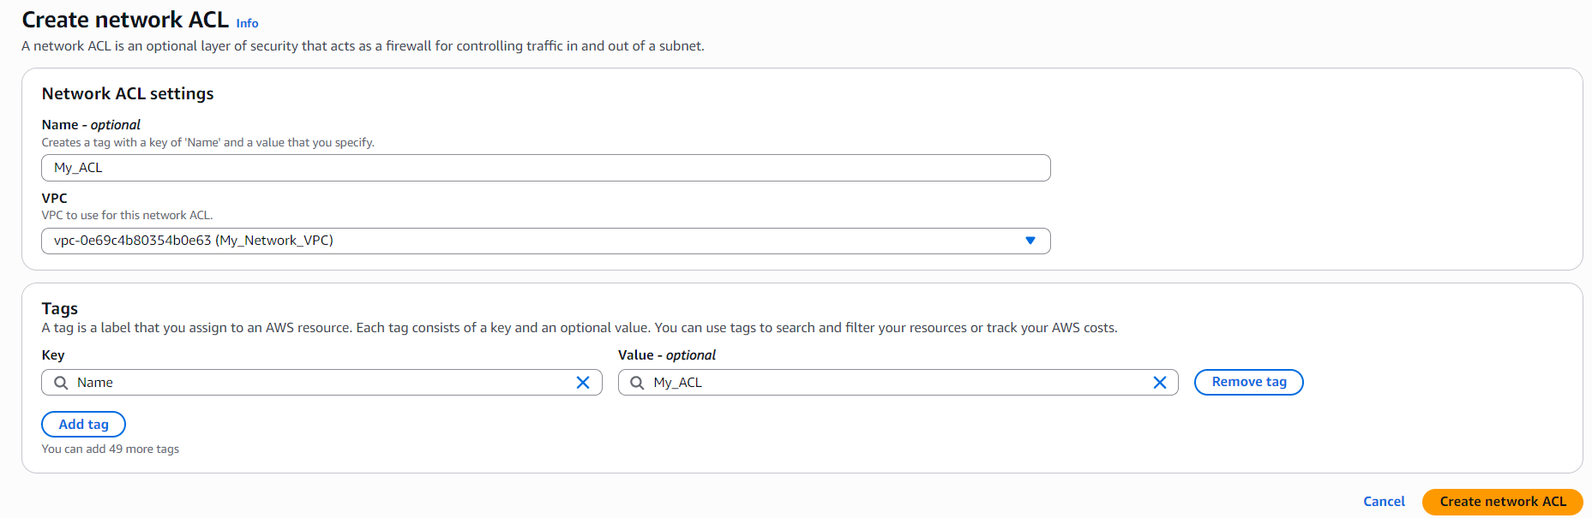
Even though AWS had already created a Network ACL for my VPC, I decided to create my own custom ACL to practice.
- I clicked on Create ACL.
- I gave it the name My_ACL.
- I selected my custom VPC from the list.
This created a new Network ACL that I could later configure with custom inbound and outbound rules to control traffic at the subnet level.
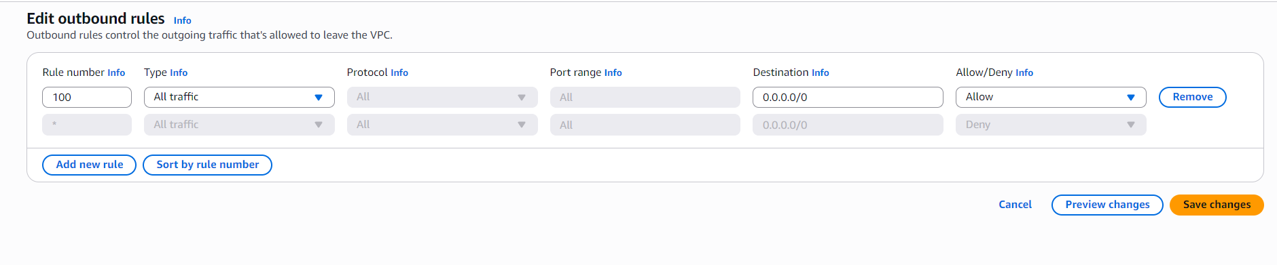
When the ACL was created, I noticed that its default rule was to deny all traffic. This means no data could flow in or out until I added specific rules.
I then proceeded to add custom rules for both outbound and inbound traffic:
- For outbound traffic:
  - I chose rule number 100 — I selected a higher number to give it lower priority, since ACLs evaluate rules in order from lowest to highest.
  - I set the Type to All Traffic.
  - Destination was set to 0.0.0.0/0 to allow traffic to any IP outside the VPC.
- For inbound traffic:
  - Similar to outbound, I set the Type to All Traffic.
  - Here, instead of destination, I used Source as 0.0.0.0/0 to allow incoming traffic from anywhere.
Finally, I clicked Save changes.
By doing this, I ensured that my subnet could send and receive traffic while still being controlled by the ACL rules — creating a secure, functional network environment.
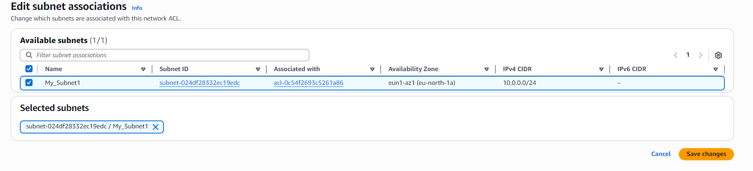
- On the selected ACL, I went to the Subnet Associations section in the bottom panel and clicked on Edit Associations.
- I simply selected my subnet to associate it with the ACL and clicked on Save.
This step is important because Network ACLs only take effect when they are associated with a subnet. Without this association:
- The ACL rules would not apply to any traffic.
- The subnet would remain unprotected at the network level.
- Inbound and outbound traffic would bypass the ACL entirely.
By associating the ACL with the subnet, I ensured that all traffic entering or leaving the subnet would be evaluated against the rules I configured, providing an extra layer of security beyond the security groups.
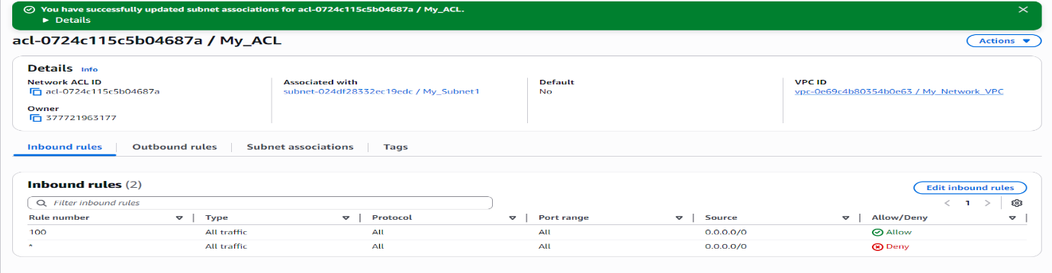
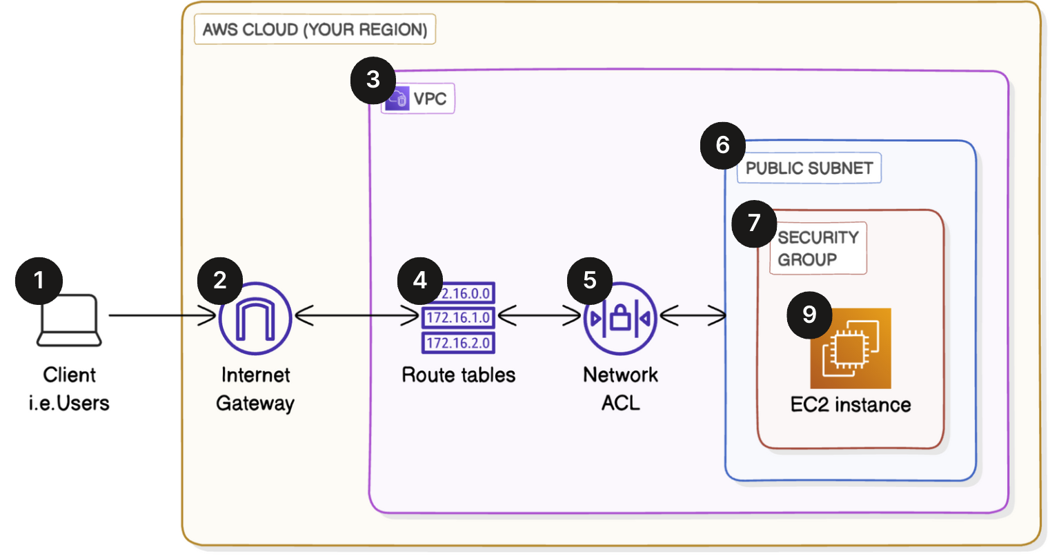
After completing all the steps, everything was fully set up. My VPC now had:
- A route table directing traffic to the internet,
- A security group controlling inbound and outbound traffic at the resource level, and
- A Network ACL providing subnet-level traffic filtering.
With these components in place, the VPC was secure, organized, and ready for resources to communicate internally and externally.

Conclusion
This project allowed me to gain hands-on experience with VPC traffic flow and security in AWS. By building on the foundation of my VPC, public subnet, and internet gateway, I was able to implement essential networking and security components to create a functional and secure cloud environment.
Key takeaways from the project include:
- Route Tables: I learned how to define routing rules to direct traffic both within the VPC and to the internet, ensuring proper connectivity for resources.
- Security Groups: I understood how to protect individual resources by allowing or restricting traffic based on IP, protocol, and port numbers.
- Network ACLs: I gained insight into subnet-level security, controlling traffic at the entry and exit points of the subnet with stateless rules.
- Subnet Associations: I realized the importance of linking route tables and ACLs to subnets to make the rules effective.
Overall, this project helped me think like a cloud/network engineer, understanding not just how to create resources, but how to secure and manage traffic flow in a real-world AWS environment. It reinforced the importance of layered security and proper traffic management in designing scalable, safe cloud architectures.

